**Course Pilot Manual**



Contents

Introduction 3

Application overview 3

System Requirements: 3

Getting started 3

Main interface 3

Login and register Screen 4

Home page 5

Add Module Page 5

Study Page 8

In the create study records page 9

Graph page 10

Benefits, appearance, and features: 11

Support and Contact Information: 11

# Introduction

Welcome to Course Pilot! This user manual will guide you through the features and functionality of our application, enabling you to create and manage your own modules with ease.

# Application overview

Users of the software Course Pilot may design, personalize, and manage their modules. For example, entering the module code, name, credits and other information and it offers a user-friendly interface. It also has options for recording the number of hours spent studying for a module, calculating the minimum hours to study per week and a graphical representation of the weekly hours studied for each module.

# System Requirements:

* Operating System: Windows 10 or later, macOS 10.12 or later.
* Processor: 2 GHz or faster.
* Memory (RAM): 4 GB or more.
* Disk Space: 200 MB or more.

# Getting started

After launching Course Pilot, you will be greeted with the Login and register page. Once you have logged in, a couple of links will appear on the home page, which serve as the navigation hub for the different features of the application which include the modules, study records and graph links.

# Main interface

The Home page of Course Pilot allows you to access various functionalities:

* New Module: Clicking this button will take you to the Module creation page.
* Study: This option lets you view and create a new study record for a chosen module.
* Graph: This option allows you to choose a module and view the number of hours you have studied per week.
* A toggle button for light and dark mode.
* A logout button

## Login and register Screen

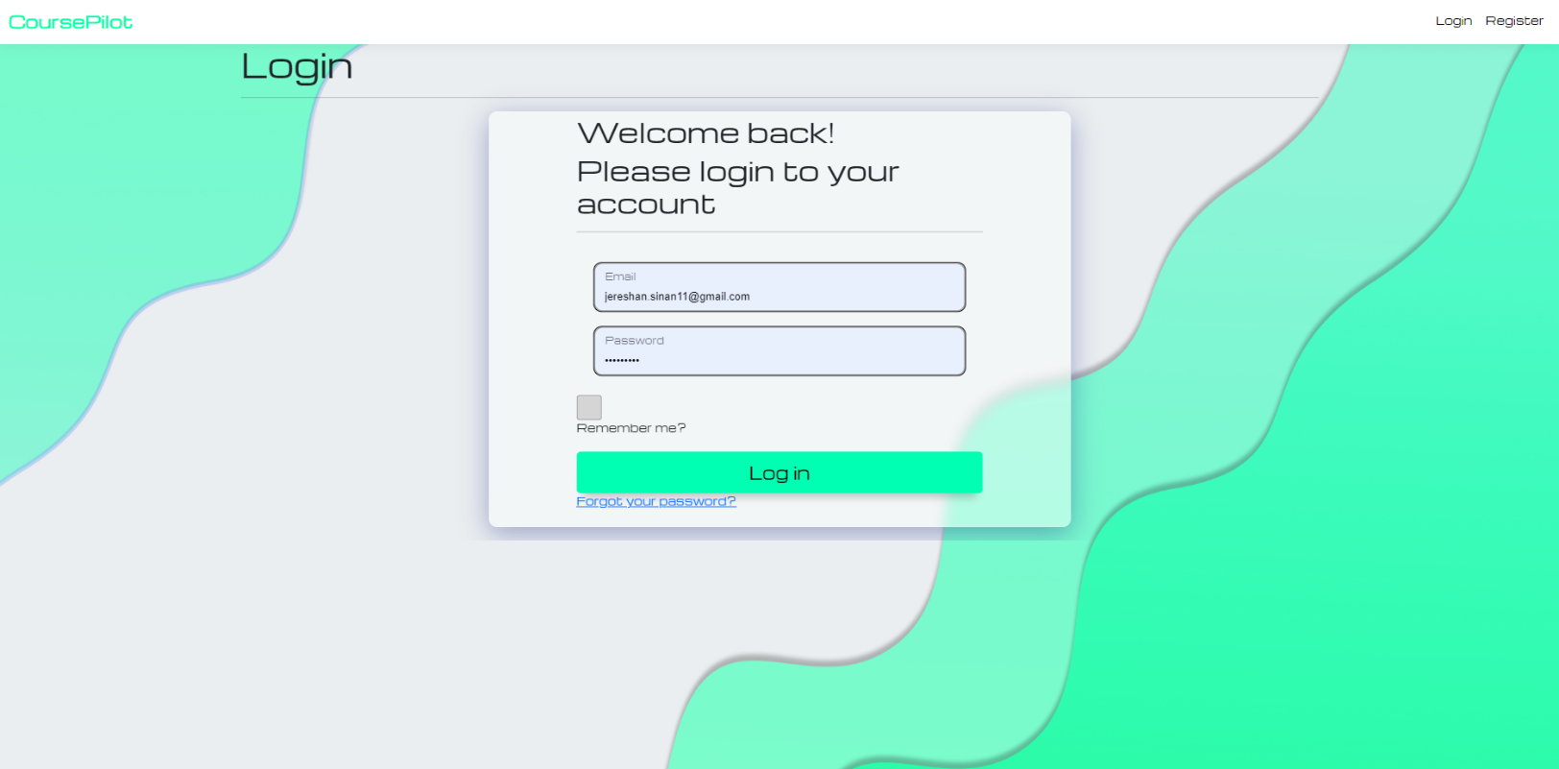This Page allows you to login or register an account. Both pages have the same layout. After a successful registration, you will be redirected to confirm your account and login directly after.

Figure Splash Screen for loading

## Home page

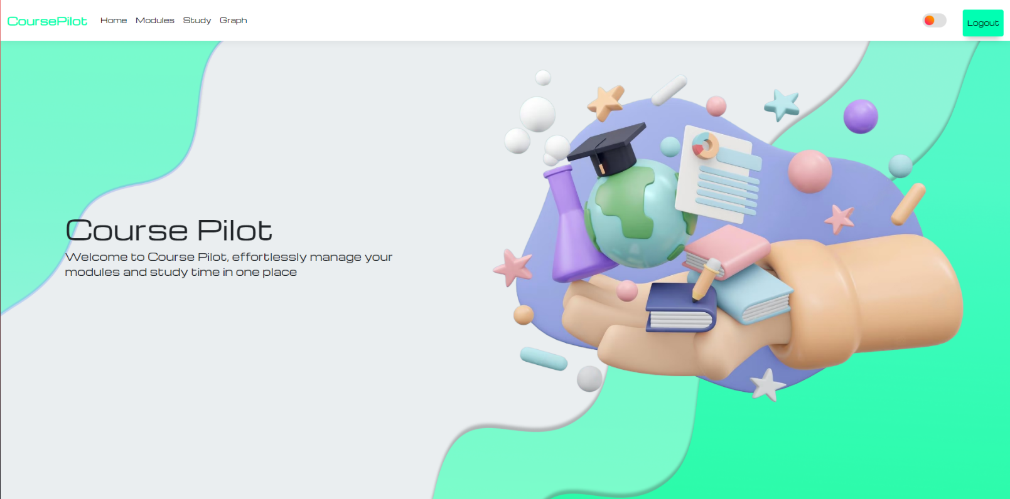This page is used to navigate the web app. It includes the links for adding a new module, creating recording study hours and the graph page. NB. Note that you must enter a have modules created and have studied at least 1 week before accessing the graph link. You also cannot access the other links once you have logged in.

Figure Home page

## Add Module Page

This Page allows you to enter the module details.

You must enter all fields to be able to create a new module, error handling has been implemented so you cannot enter incorrect data in the fields. Additionally, you will be able to view the details of the module and delete and module.

**Fields:**

* Module Code. Example; PROG6212
* Module name: The name of your Module. Example; Programming
* Credits: The number of credits offered for that module. Example; 20
* Weekly class hours: The number of weekly hours you have for that module. Example; 5
* Weeks in semester: The number of weeks in the semester. Example; 10
* Start date: The start date for that module chosen from a calendar.

After creating a module, you will be redirected back to the modules page, where all the modules that you have created will be displayed. Based on the information entered the self-study hours per week will be calculated using this formula: self-study hours per week= number of credits × 10 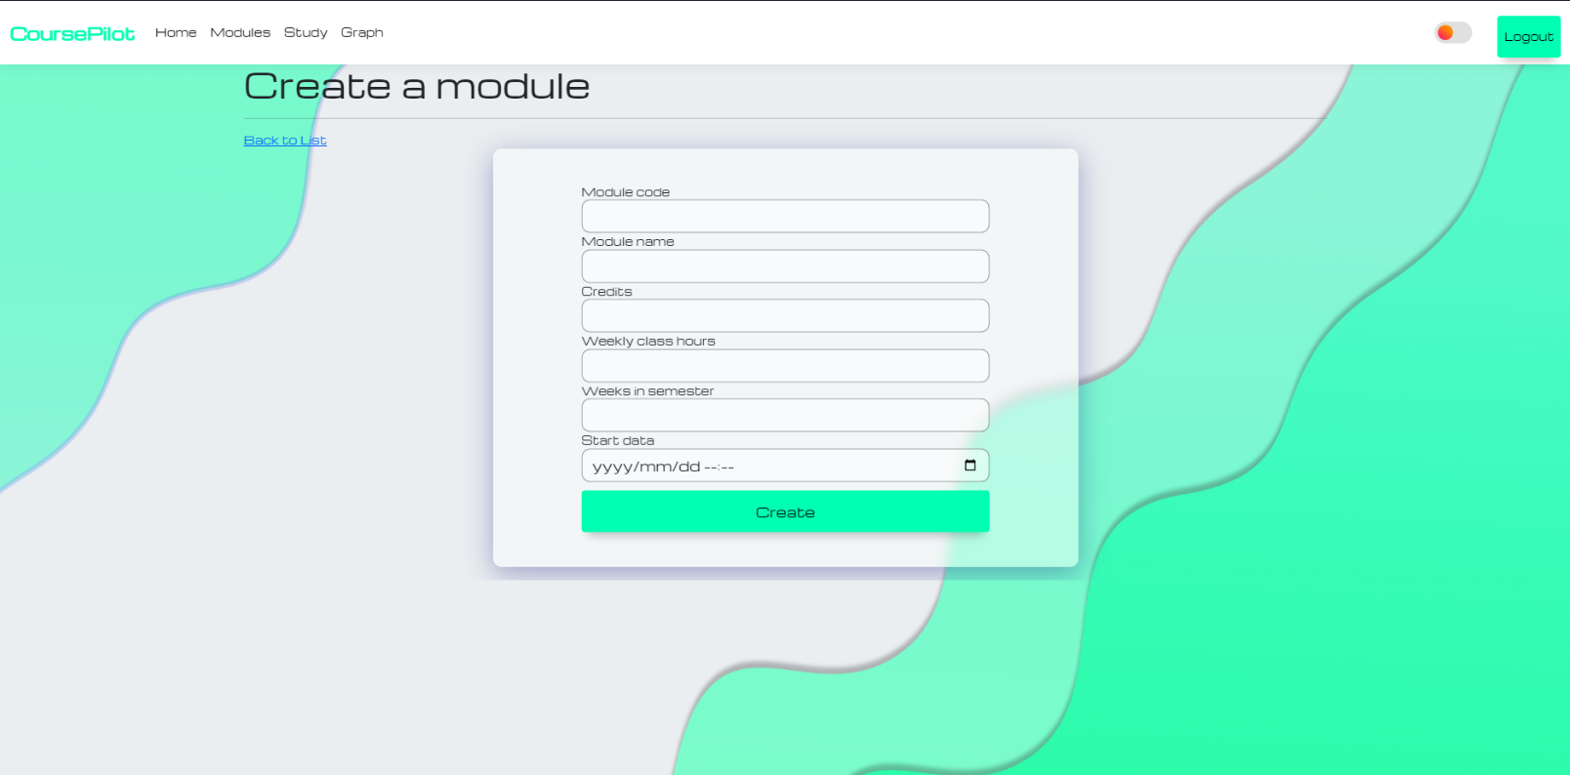number of weeks − class hours per week

Figure Add module page.

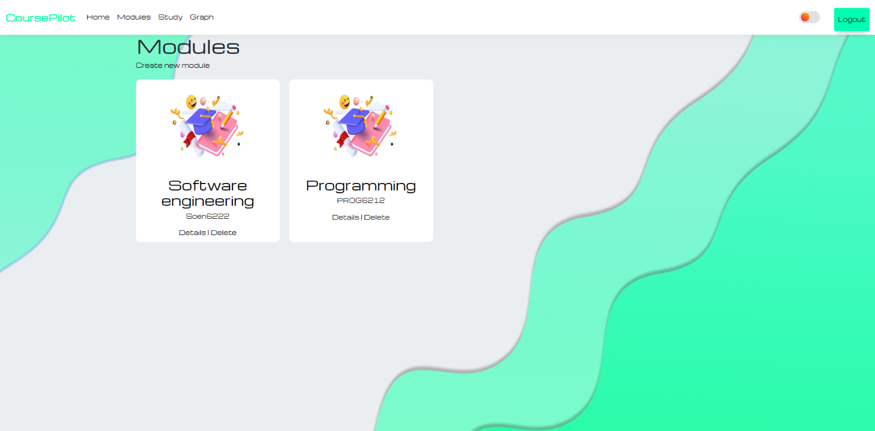The following image, figure 4, shows what your modules page should look if the module creation was successful.

Figure Modules page

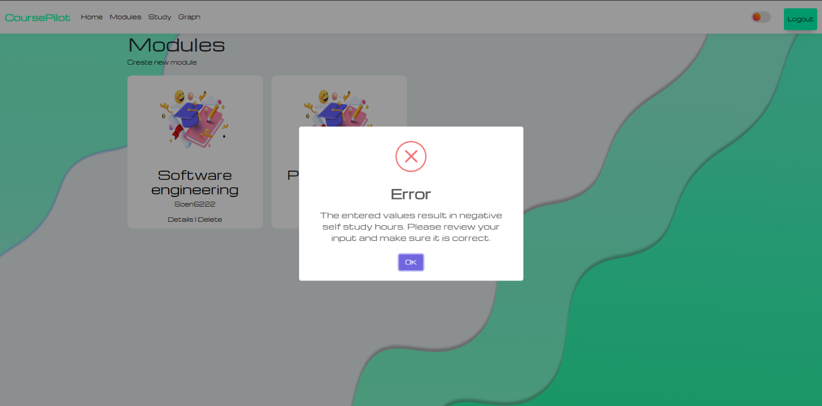Figure 5 shows that if the module creation was unsuccessful such as adding values that result in negative output, an error message will be displayed.

Figure Error message

## Study Page

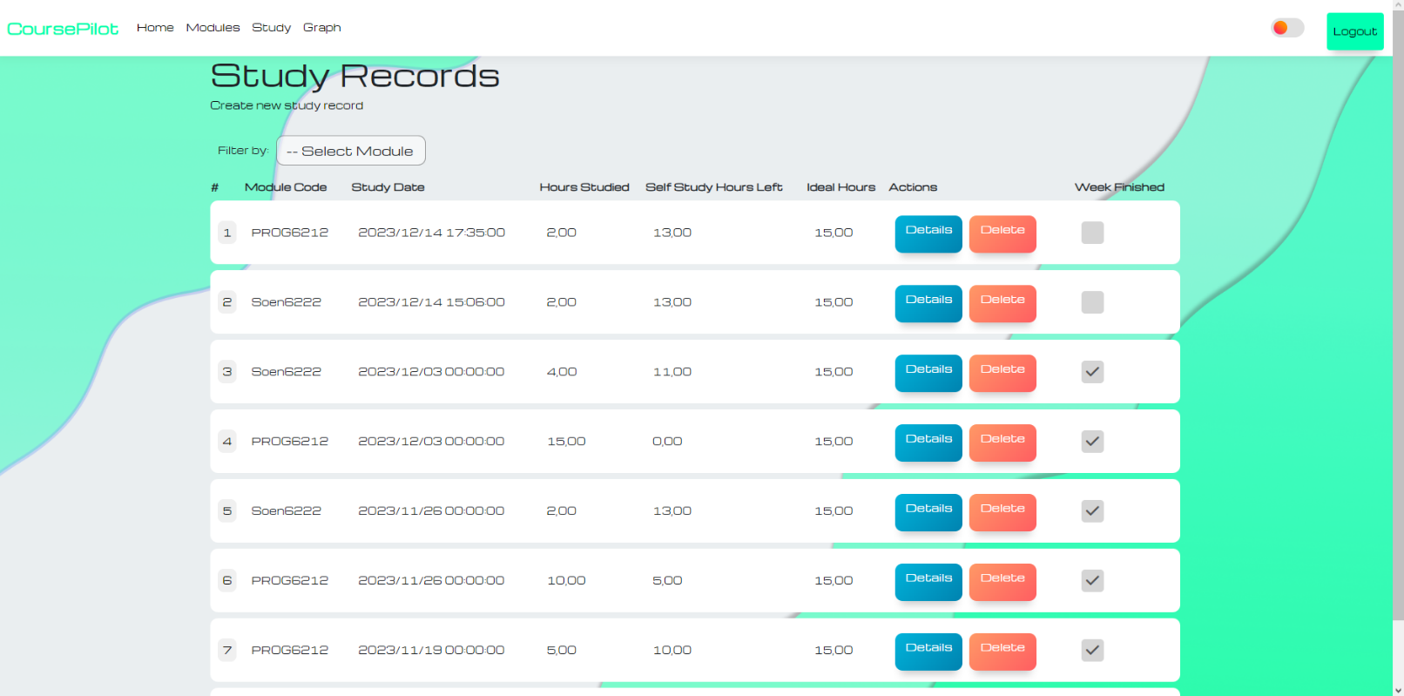This is the Study records page that will have all the records that you have created for all modules. To make it easier, there is a filter option to only display modules that you would like to view.

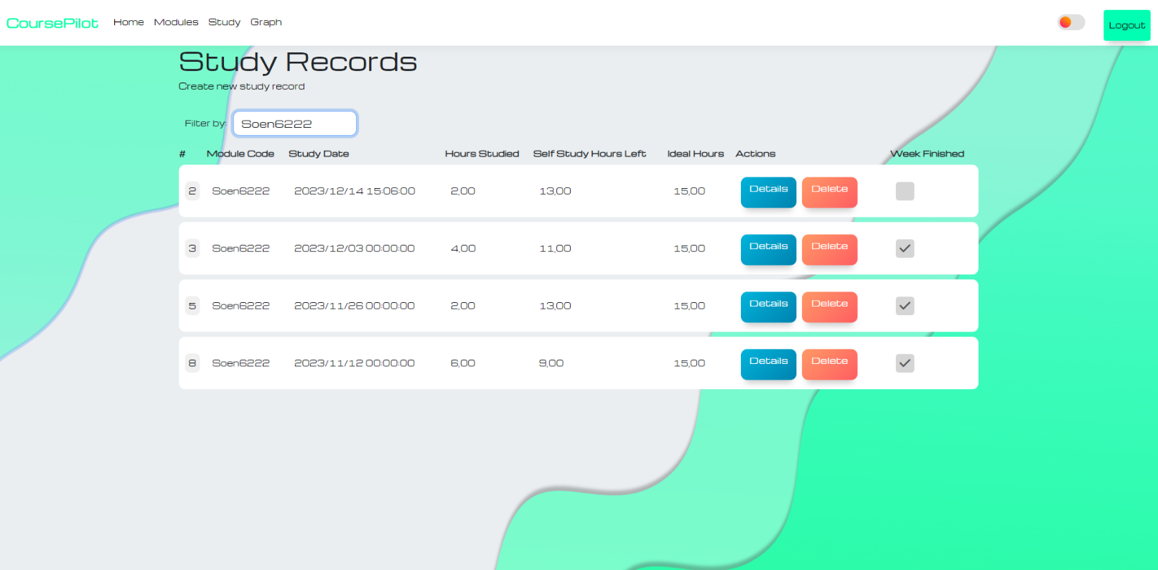Figure All records

Figure Records filtered by module.

## In the create study records page

This window allows you to choose a module from a combo box, enter the study date and hours studied for that module. After a successful record creation, it will be added to the study records page. Each record will display:

* a number,
* module code,
* study date,
* hours studied,
* hours that are left,
* ideal hours
* Action buttons(details and delete)
* Week finished checkbox(Read only)

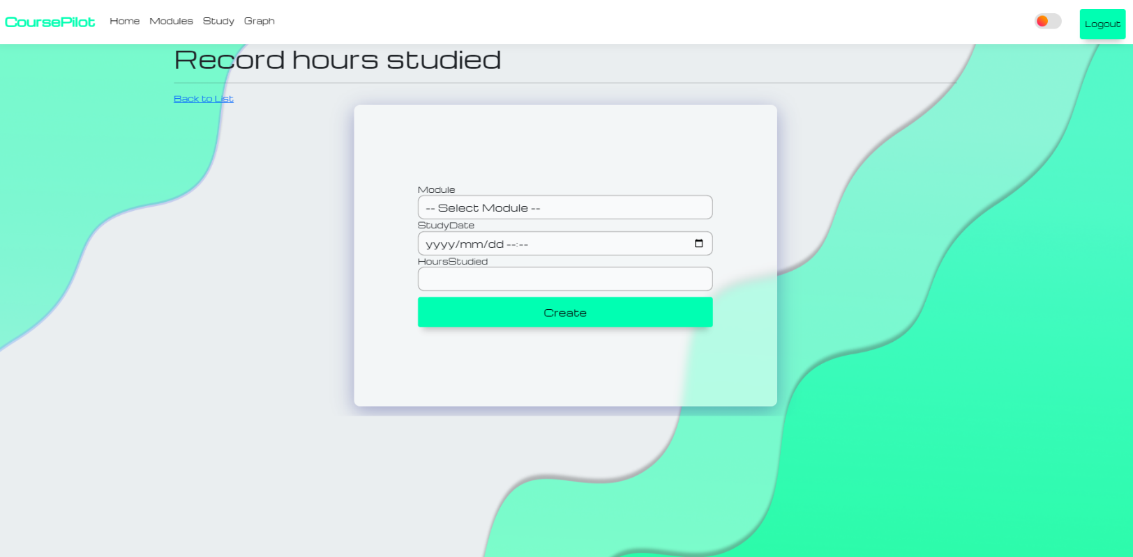As soon as you have entered a study record that starts in a different week, all records in the previous week will be combined. It will add all the hours studied and calculate the start date of that week. The total hours studied will be displayed in the hours studied column and the study date will contain the week start date. Additionally, the week finished checkbox will be checked notifying the user that the previous week has been completed.

# Graph page

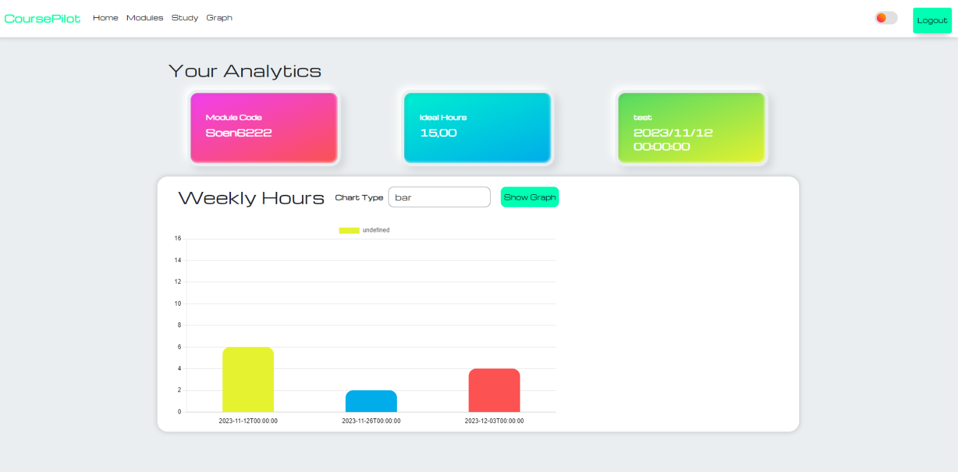Course pilot allows you to view the total hours you have studied per week in the form of a graphical representation. These include the bar, line, pie, and doughnut variations. Simply choose the desired chart in the combo box and click the show graph button. Additionally, the module code, total hours studied, and the ideal hours are displayed.

# Benefits, appearance, and features:

Course pilot enables you to seamlessly create modules, record study hours and view the data on a graph.

Efficiency and Organization: By using this application, you may store and manage all your modules wherever as long as you have a browser. You no longer fall behind work and have a more organized semester.

Anywhere Access: You can see manager modules from anywhere as long as there is an internet connection and a browser. This makes it reliable as you can manage your modules from university or at home.

User-Friendly user interface: Course Pilot includes pleasing backgrounds and background images to make it easier to use and navigate. It includes a dark mode option if you prefer the aesthetic of a dark mode interface. All background images were made using Figma.

# Support and Contact Information:

For further support or inquiries, please contact me at: Email: [st10033851@vcconnect.edu.za](mailto:st10033851@vcconnect.edu.za)